
A 12
Sreenidhi Institute of Science & Technology
(An Autonomous Institution)
Code No: 121MA04

B. TECH. I – Year II – Semester Examinations, July, 2013 (Regular)
ENGINEERING MATHEMATICS - II FOR BIO-TECHNOLOGY (BT)

Time: 3 Hours Max. Marks : 70

Note : No additional answer sheets will be provided.

Part-A (Objective Type)
Max.Marks:20

Answer all QUESTIONS.

1. Define a linear differential equation.
2. What is Laplace transform of unit step function 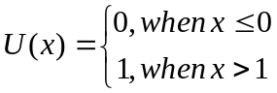.
3. Does divergence of Curl of a vector point function 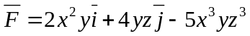exist? If so, find it.
4. Form the partial differential equation from z=f(x²-y²).
5. Do the solutions y=sinx and y=cosx are linearly independent solutions of the differential equation 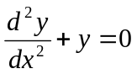.
6. If F(x) = L(f(t)), then what is L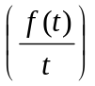.
7. Find the Fourier series of f(x)=sinxin(-π,π).
8. State stoke'e theorem.
9. Define Newton's Law of cooling.
10. f(t) is defined in (-C,C) and periodic. Write the Fourier series of f(t).
Part – B
Max. Marks: 50

ANSWER ANY FIVE QUESTIONS. EACH QUESTION CARRIES 10 MARKS.

1. a) Solve the differential equation 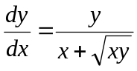. [ 5 ]
b) By the method of variation of parameters, solve (D²+a²)y=sec ax. [ 5 ]

2. a) Find the orthogonal trajectories of the family of parabolas y²=4ax. [ 5 ]

b) Solve the differential equation (D²+4D+4)y=e^{2x}. [ 5 ]

3. a) Find the Laplace transform of tsin2t. [ 5 ]

b) Find the Laplace transform of 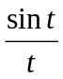. [ 5 ]
4. Find the inverse Laplace transform of 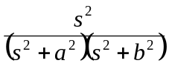 using convolution theorem.

5. Verify divergence theorem for F=(x²-yz)+(y²-zx)+(z²-xy)taken over the rectangular parallelepiped 0≤x≤a, 0≤y≤b, 0≤z≤c.

6. a) Solve x²(y-z)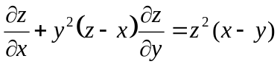. [ 5 ]
b) Solve the partial differential equation p+q=pq.

7. Find Fourier series of f(x)=|x| and hence show that 1+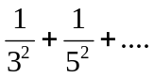=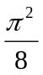.

8. a) If the air is maintained at 30⁰ C and the temperature of the body cools from 80⁰ to 60⁰C in 12 minutes, find the temperature of the body after 24 minutes. [ 5 ]

b) Solve (D²+4D+3)y=e^{-x} sinx+x. [ 5 ]

-- 00 -- 00 --

